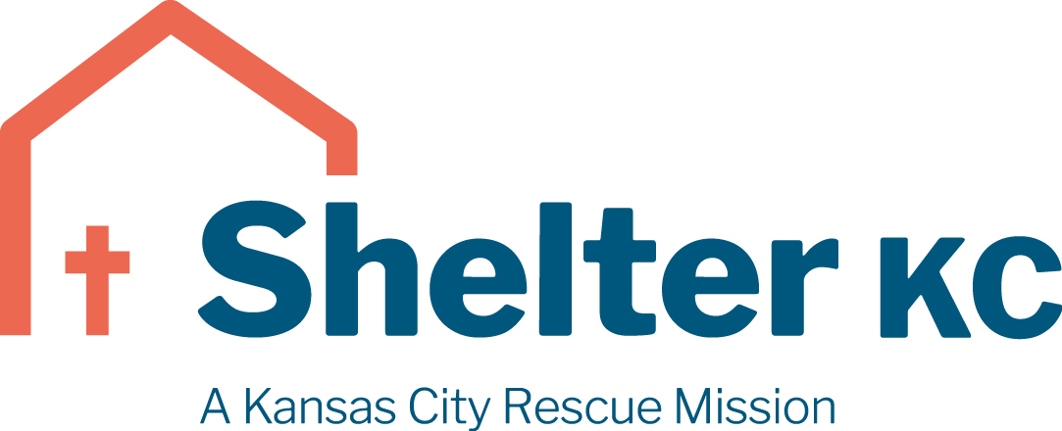

Men’s Lead Recovery Coach
Shelter KC is hiring a Lead Recovery Coach to serve in our Men’s Center. Shelter KC is a Christ-centered community serving among the poor and homeless of Kansas City. We offer hope and the opportunity for reconciliation and transformation through programs of relief, recovery and reentry, empowering those we serve to reach their full potential.
Primary Job Responsibilities include but are not limited to:
- The C-COR Lead Recovery Coach must be able to demonstrate knowledge and skills necessary to provide care and guidance to C-COR Participants. The person must possess the competence to gather and interpret information about the client’s physical, social, emotional, and spiritual status. The person must also have the competence to develop recovery-planning services according to the bio-psycho-social-spiritual influences and effects of dependency.
- Maintain a welcoming and healthy environment for those seeking our services
- Coordinate the team and resources to meet the core needs of our recovery participants.
We are hiring one full-time employee for this position. Shift is scheduled Mon – Fri (8:00am – 4:30pm) 8 hours per day. Full-time positions offer life insurance, health insurance, dental insurance, generous paid time off, and a retirement plan.
All staff are required to adhere to and fully support Shelter KC’s Mission Statement, Core Values, and Statement of Belief which can be found here: https://www.shelterkc.org/about/employment/
To apply, please visit https://www.shelterkc.org/about/employment/
Starting pay – $45,000 per year *Based on job experience and expertise.

